How to Pull Chapter Membership Rosters in Billhighway

- Log into bill highway
- Navigate to Reports > click on down arrow
- Click on online inquiries > membership roster
- Click on find by > group name
- Choose chapter if it does not automatically default to the assigned chapter
- Membership status select category
- For membership it is recommended to check all at the top to not overlook any category
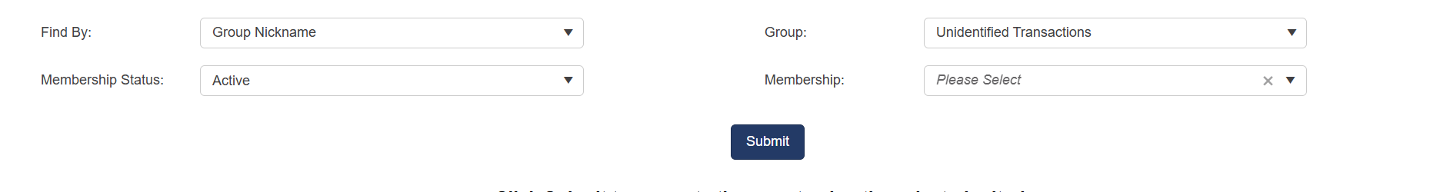

- Then use the middle X button to export the list to excel from Billhighway
