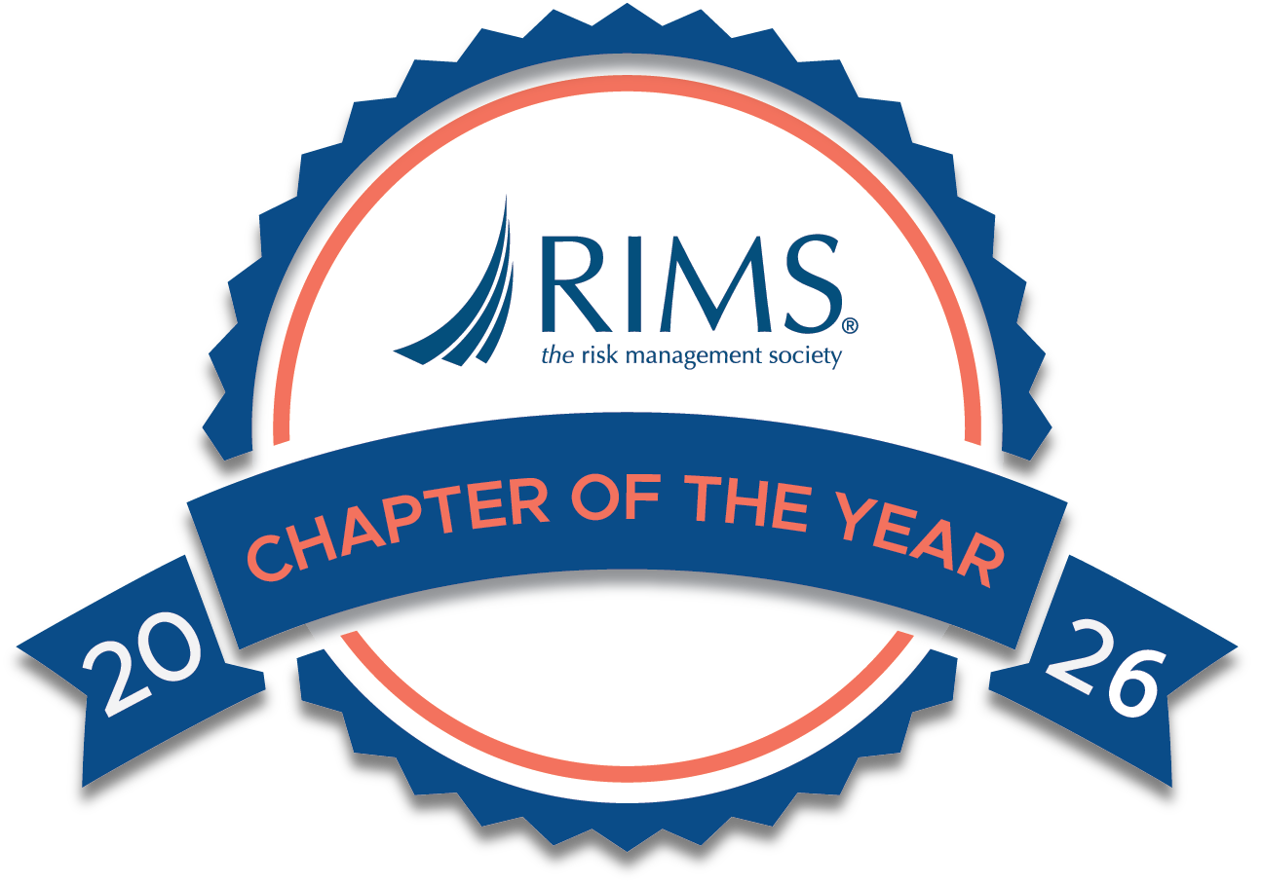

RIMS Chapter Awards Strategic Planning Template
and Award Submission Form

- Use the template below to outline your goals to enhance chapter outcomes. Show progress towards attaining these goals and any challenges that you encountered. Share lessons learned, not just successes.
- Chapter best practices will be shared with fellow chapter leaders and honorees will be asked to participate in the RIMS Chapter Leadership Forum at RISKWORLD. Best practices include:
  - Creating SMART goals (Specific, Measurable, Actionable, Realistic, Timely)
  - Timing to provide for adequate planning (e.g. setting goals 12 months ahead of award submission)
- RIMS will review each submission and select a Chapter of the Year and up to four (4) additional honorees.
- Track your progress and submit to Eric Bernard at ebernard@rims.org by Friday, January 16, 2026.

Chapter Name: __________________________________ Chapter Contact Name: ___________________________
Contact Phone: ________________ Contact Email: _________________________

# 1 Goals for the Year – 20 Points
Outline chapter goals (2-3 max) and define success for each.
Goal |  |  | Success Metric (Quantifiable)
1.
2.
3.

#2 Why? Why this? Why Now? – 15 points
Briefly explain any notable chapter developments/challenges over past 2 years that led to you setting these goals.

#3 How will you complete these goals? – 15 points
Provide a short summary of the strategy to improve your chapter over the award year.

#4 progress – 30 points
Track your progress at regular intervals. Share challenges encountered and the adjustments made along the way. Please include pertinent data and metrics that you have used in evaluating and measuring progress.

Goal | Review Date (regular intervals) | Key Milestones (Progress Towards Achieving Goal)
1.
2.
3.

#5 Results and/or lessons learned - 20 points
Did you meet your goals? Report on success metric results as well as any lessons learned. If the chapter’s definition of success has changed over the course of the program year, please indicate your thinking and what factors led to that decision making.
Goal | Success Metric (did you achieve #1) | Results and/or Lessons Learned
1.
2.
3.

