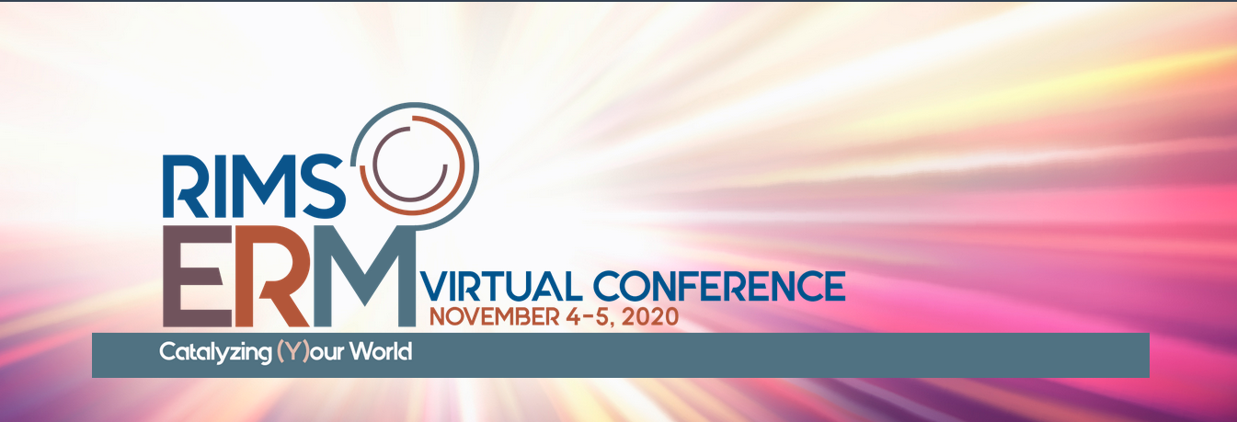
RIMS 2020 Global ERM Award of Distinction
Nominations MUST be submitted by August 21, 2020.
Please complete the official form (see below), save in PDF format, and email submission to: ERMaward@RIMS.org
Each year, RIMS honors leading ERM programs that demonstrate innovative approaches and techniques to managing uncertainty effectively with the aim of creating, preserving or realizing organizational value. Be recognized for ERM excellence and join a global community of experts by sharing your organization’s approach for managing today’s risk and opportunity landscape with your peers.
IS YOUR ERM PROGRAM AWARD-WORTHY?
RIMS is looking for ERM excellence that:
- Demonstrates ERM innovation in creating and preserving organizational value.
- Provides measurable, tangible and sustainable results for their organization.
- Is transferable to other organizations.
We seek entries that describe new approaches for managing uncertainty effectively, which includes risk and opportunity linked with strategy and performance. We invite you to describe your ERM program, and highlight how it is enabling leadership to manage an evolving risk and opportunity landscape in achieving the objectives desired by your organization.
AWARD PROCESS
- Please complete the official form, save to PDF format. Note: electronic file size cannot exceed 9MB.
- Submit entry on or before August 21 2020 by emailing the completed official nomination form to ERMaward@RIMS.org
- An independent judging panel will review the entries to select an overall winner or winners, if any.
- The judging panel may require additional information or a Question & Answer session with the ERM lead to clarify items on an entry. Responses are due within the time noted in the request.
- The panel’s decisions will be final, including whether entries are eligible and, at the panel’s discretion, whether honorable mention or sector awards are given.
- RIMS will contact winner(s) no later than October 1, 2020 and invite the ERM leader (or member of the winning organization’s leadership team) to accept its award at the RIMS ERM Conference 2020 on Wednesday, November 5, 2020. Winner(s) will receive one complimentary registration for the entire RIMS ERM Conference. Attendance at the ERM Conference is not a condition for winning the award.
- Direct any questions to ERMaward@RIMS.org.

RIMS 2020 Global ERM Award of Distinction
Official Nomination Form
Date of Submission:
Organization Being Nominated:
HQ Address:
City, State (or province), Country, Postal Code:
Organization Type (privately held, publicly held, government entity, nonprofit)
Annual Revenue (USD): | Total Number of Employees: | Year Founded:
Submission completed by:
Submitter’s Name: | Submitter’s Organization:  (if different from Nominated Organization): | Email:  Phone: | Signature or Electronic Signature:
Name of ERM Program Leader at Nominated Organization: | ERM Program Leader Title | Email:  Phone: | Signature or Electronic Signature:

RIMS intends to honor and recognize organizations through its ERM Award of Distinction program in accordance with the quality criteria as determined by RIMS. The RIMS judging panel, in its sole discretion, determines whether the award winner(s), if any, meet(s) the award qualification requirements.
By submitting the entry, the nominated entity agrees that RIMS may feature the award on RIMS website, social media or through other channels if selected. RIMS communication department will work with the winners on press releases, announcing award recipients and other information.
RIMS expects that the risk management professional(s) of the awarded entities would be willing to share their winning approaches, innovations, techniques, templates or practices with peers and practitioners through the RIMS network, such as webcasts, podcasts, articles, conference presentations or contributions to the RIMS ERM resource library.
The signature(s) on the entry form constitute the entrant’s understanding and agreement with these criteria and processes.
RIMS 2020 Global ERM Award of Distinction

Organization Name:

- Why do you consider your organization’s ERM program to be successful, and how do you measure this success? (Typed response must use Calibri 11 font and fit on this page.)*
*Please note, if the response exceeds this page, only the content that is contained on this page using Calibri 11 font will be judged.

Organization Name:

- What are the unique strengths of your organization’s ERM practices? For example, how is risk and opportunity thinking integrated across your organization to enable understanding and proactive management of uncertainty, to create, preserve or realize organizational value? Please be specific. (Typed response must use Calibri 11 font; 300 words maximum.)*
Please note, if the response exceeds the word limitation only the allowed number of words will be included for judging.
You may attach a presentation, framework, tool or template, modified so that it can be shared with RIMS members and member practitioners.

Organization Name:

- Describe an ERM innovation that links risk with strategy or performance by your organization in the last 2 to 3 years. The innovation may be a new or radically enhanced process or technique created and implemented by the ERM function to address uncertainty or solve a challenge. Describe the problem or what led to the innovation, and how the solution was implemented. Please include measurable impact, benefits to internal or external stakeholders, and any lessons learned. (Typed response must use Calibri 11 font; 500 words maximum.)*
* Please note, if the response exceeds the word limitation only the allowed number of words will be included for judging.
You may attach a presentation, framework, tool or template, modified so that it can be shared with RIMS members and member practitioners.

Organization Name:

- Describe how your ERM program builds risk culture and sustaining capabilities for actively managing emerging uncertainty, or builds learning for continuous improvement, or governance and communicating with stakeholders, or measuring performance within your organization. (Typed response must use Calibri 11 font; 300 words maximum.)*

* Please note, if the response exceeds the word limitation only the allowed number of words will be included for judging.
You may attach a presentation, framework, tool or template, modified so that it can be shared with RIMS members and member practitioners.

Organization Name:

- You may comment on other value derived from success of your organization’s ERM program that you wish the panel to consider. (For example, innovation, partnerships, communication, awareness, adaptability, influences, etc.)

- Please provide one (1) to three (3) user testimonials including from the organization’s leadership team. You may also add a statement from a third party organization that can attest to your organization’s ERM excellence. Testimonials must include name and title.

